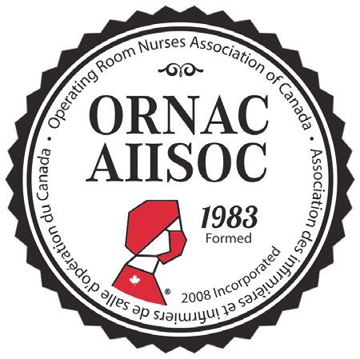

VIRTUAL EXHIBIT HALL PROSPECTUS
Dear Industry Partner,

Welome to ORNAC’s 27th National Conference! While it’s unfortunate that we couldn’t see you in person in Victoria, British Columbia, we are absolutely thrilled to have you join us at our first innovative Virtual Conference. In order to help prevent the spread of COVID-19, it was with much deliberation, care and concern for your health and safety, that the ORNAC Board of Directors made the decision to transform the ORNAC National Conference to an online Virtual Conference, which will take place during the same time frame - April 29 - May 2, 2021.

Connect and network with many Perioperative clients and affiliate companies at the most highly anticipated event for the Perioperative nursing arena in Canada! Due to the global pandemic and restrictions with face-to-face meetings, we have gone virtual! This ORNAC Conference will provide amazing educational sessions designed to generate ideas and promote new thinking, the latest technology and trends, along with live Question and Answer sessions after each presentation.

As an Industry Partner, you will have the unique opportunity to interact with our delegates, explore our wide-ranging educational program, and showcase your amazing products all on one platform and all from the comfort of your remote workspace through your Virtual Exhibitor Booth.

The best part is that your Virtual Exhibitor Booth and the Virtual Exhibit Hall are going to be available long after the conference is completed - this means that your product education, literature, videos, and more will all be accessible by others for months after the final session ends. We will be connecting the Virtual Exhibit Hall to our main www.ornac.ca website after the conference to make this available to other conference registrants in the future.

As we know many elements of your company’s marketing might change over the course of the next year, we will make sure that you will be able to easily update information, files, and links whenever necessary.
OUR GOALS
- Demonstrate value for your company
- Create an ongoing sustainable partnership with ORNAC
- Develop an infrastructure to ensure seamless execution of education...face-to-face or virtually

Step-by-step, this document will help guide you through the process of populating and updating your Virtual Exhibit Booth: your home for all your key products, literature, company education, videos, your team, and lead generation.

Ultimately, we want to build something as close to the face-to-face experience you would have had at our in-person conference plus include a few more features you wouldn’t have been able to access in- person!

VIRTUAL EXHIBIT HALL PROSPECTUS
PROSPECTUS TABLE

Platinum $15,000 | Gold $10,000 | Silver $6,000 | Bronze $3,500
Prior | ity logo positioning in Vi | rtual Exhibit Hall
1st Position  Opportu | 2nd Position  nity to host an Education | 3rd Position  al Breakfast/Lunc | 4th Position  h
Applicable  ($4,000 additional cost to host/provide speaker for breakfast education session) | Applicable  Recognition of Sponsorsh | Not Applicable  ip of Sessions | Not Applicable
Keynote and Closing Session (2 available) | Sponsorship of Regular Sessions  Journal Advertis | None  ing | None
*Full page colour cover position ad  (inside front, inside back, or outside back cover, as available**) Retail value: $2,380 | Full page colour ad Retail value: $1,985  Number of Exhib | Half page colour ad Retail value: $1,500  itors | Quarter page colour ad Retail value: $1,120
Unlimited | 8  Rapid Fire Sessi | 6  ons | 4
20min rapid fire session  (15min presentation, 5min Q&A)  Pop- | 15min rapid fire session  (10min presentation, 5min Q&A)  Up Message in your Virt | None  ual Exhibit Booth | None
Applicable  Use this tool to run a giveaway contest, promote a product, ask attendees to  join a mailing list, and more! | Not Applicable | Not Applicable | Not Applicable
Additional opportunities
If you’re interested in further sponsorship opportunities such as a sponsored session, please contact info@ornac.ca.
Confirm your spot!
Confirm your spot as a vendor at the 27th National ORNAC Conference! To confirm, please email info@ornac.ca with the level of partneship you desire.

Notes
All registered exhibitors are eligible to attend educational sessions
*one complimentary advertisement in an issue of the ORNAC Journal, of your choosing (over a 2-year period to cover the time span between conferences). A 15% discount on any additional ad bookings will also apply.
** If journal cover is not available you will receive one full page, and one half page ad instead.

VIRTUAL EXHIBIT HALL PROSPECTUS

Step 1: Company & General Information
In this section, you will provide the following information:
- 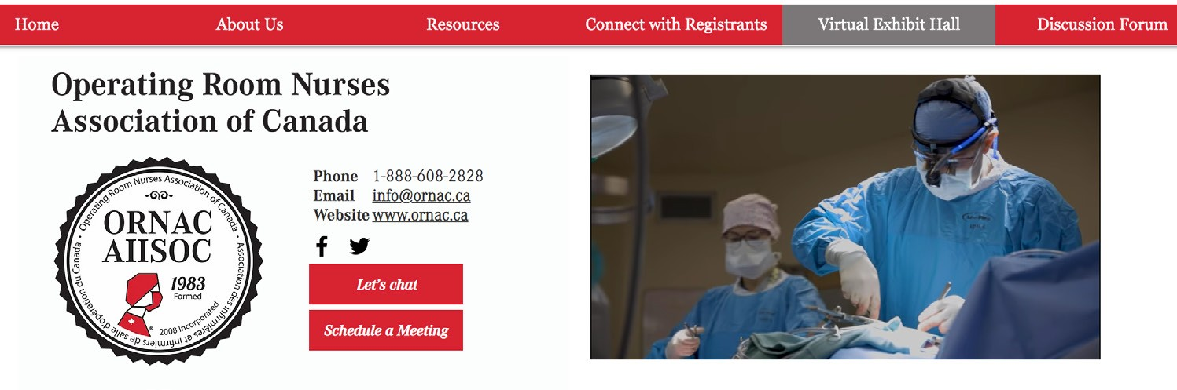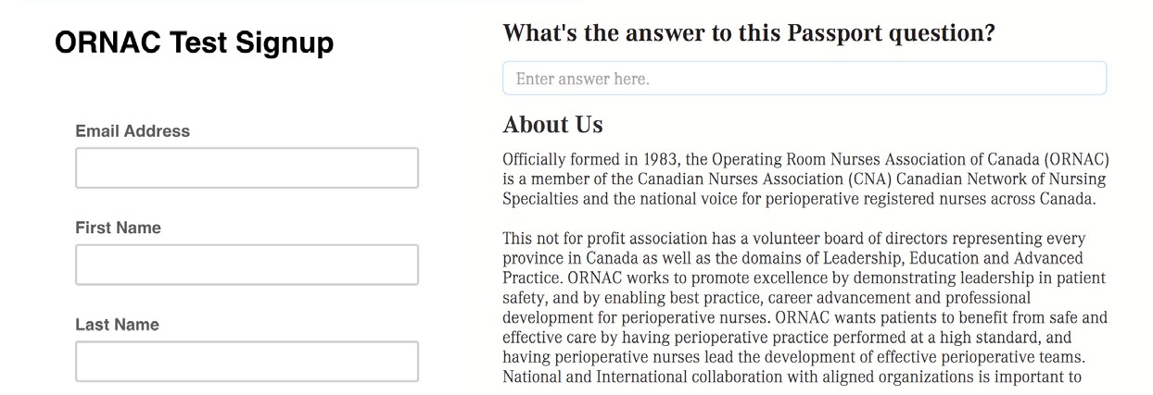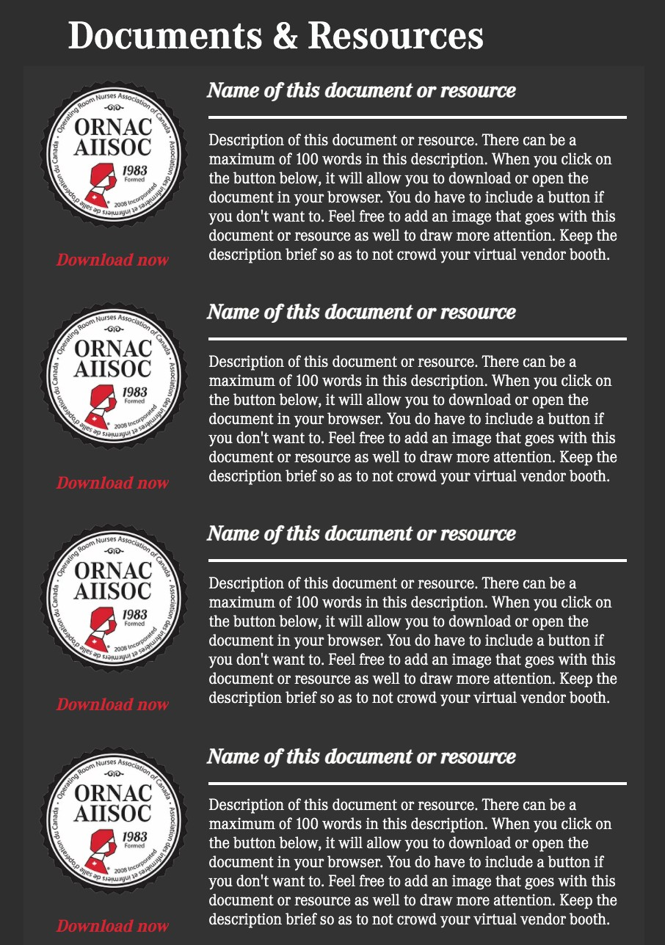Company Name (as you want it to be shown)
- Company Logo (high-res PNG file preferred - no need for vector or AI files)
- Company Website URL
- Company Social Media URLs (e.g. Facebook, Twitter, LinkedIn)
- Company Primary Email
- Company Description (a paragraph or two describing your company)
- Welcome Image or Welcome Video, which autoplays upon visting your page (optional)
- Link to embed your Lead Retrieval/Survey/Contact Form (Optional, see Step 5 for more info)
- Passport Question (see page 5 for more information)

Step 2: Product/Service Education
- Product/Service Education
Describe the type of education your company provides for product use. E.g. In-service, patient education, presentations, videos, documents, files, etc. If you do not have any education programs, you can use this section to further describe your company, products, and/or services.
- Product/Service Literature File Names & URLs
Note: Depending on your level of partnership, you will be offered to display a different number of product files.
  - Platinum Level Partners: up to 10 Products (10 Literature Files)
  - Gold Level Partners: up to 7 Products (7 Literature Files)
  - Silver Level Partners: up to 5 Products (5 Literature Files)
  - Bronze Level Partners: up to 3 Products (3 Literature Files)
- Product File URLs
Note: If you want to track the number of file clicks, all URLs should include UTMs or be generated using a link-shortening/tracking tool like bitly. This is not mandatory, but highly suggested. You can easily create a URL for your files by uploading them to your company’s website or file storage service like Google Drive or Dropbox. If you want to learn more about how to create UTMs, please click here: How to Create UTM Codes

VIRTUAL EXHIBIT HALL PROSPECTUS
Step 3: Product Videos

In this area, you will be able to provide URLs to your product or company videos. Your Virtual Exhibit Booth can only support videos posted to Youtube, Vimeo, or Facebook. You do not need to send us an .mov or .mp4 file of your videos. Please note that depending on your level of partnership, you will be able to promote a different number of product or company videos. The only information we need in this section are the video URLs.

Depending on your partnership level, you may also be able to conduct a Rapid-Fire session to demonstrate your product(s) or service(s). This Rapid-Fire session video can also be housed on your Virtual Exhibit Booth in this section as a bonus to it being included as a part of the Educational Program.

  - Platinum Level Parners: up to 6 Videos + 20min Rapid-Fire Session
  - Gold Level Partners: up to 4 Videos + 15min Rapid-Fire Session
  - Silver Level Partners: up to 4 Videos
  - Bronze Level Partners: up to 3 Videos

Step 4: Connect with your Team
In this area, you will be able to promote your Team Members, their titles, and email addresses so that visitors to your Virtual Exhibitor Booth can connect with them right away! Note: Depending on your level of partnership, you will be offered to display a different number of team members.

  - Platinum Level Partners: up to 10 Team Members
  - Gold Level Partners: up to 8 Team Members
  - Silver Level Partners: up to 5 Team Members
  - Bronze Level Partners: up to 3 Team Members
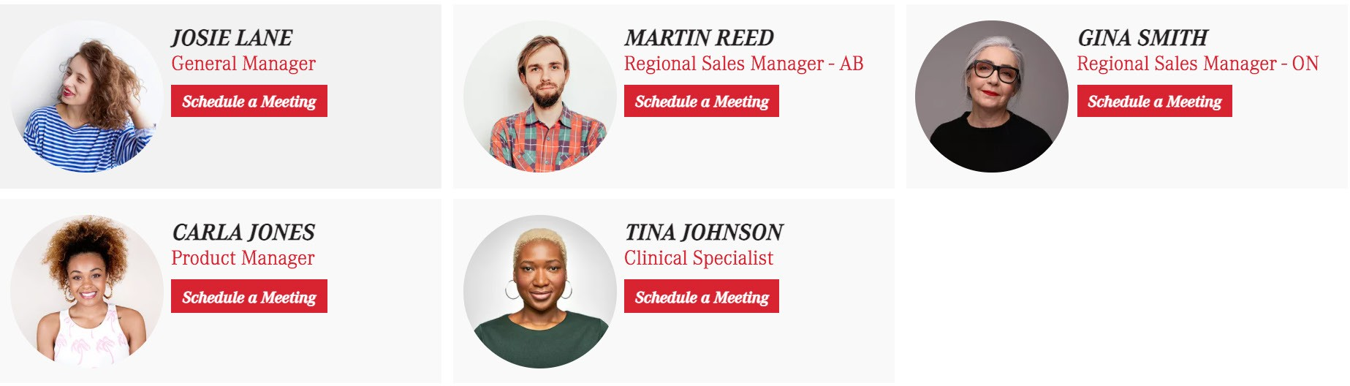

Step 5: Lead Retrieval/Contact Form
The next part of your Virtual Exhibit Booth is an area dedicated to Lead Retrieval. We want to make sure we can provide you with an opportunity to track more than just the number of clicks on different elements of your page -- we want you to connect with Virtual Conference delegates! We’ve created an area for you to add a lead retrieval form embedded right on your Virtual Exhibitor Booth.

With a form-building system you already use like SurveyMonkey, Hubspot, Mailchimp, Constant Contact, etc., you can create a form you want to see on your Virtual Exhibitor Booth and simply share the embed

VIRTUAL EXHIBIT HALL PROSPECTUS
code or URL with us. It will appear exactly as you created it in this area. When a visitor submits this form, it will automatically record the responses in your CRM or form-building system.

We encourage you to get creative with this form to incentivize visitors to complete it! Maybe you want to create a contest for all delegates who respond to a survey, or offer samples to all those who complete it.

Additional Features

Post-Conference Analytics Report
All vendors will receive a post-conference Analytics Report for your Virtual Exhibit Booth, including statistics like:
Total Page Views
Total number of times the page was viewed (repeated opens of the same page are counted). Includes Page Ranking, Site Average.
Total Sessions
Number of site sessions during which this page was viewed at least once. Includes Percentage of Site Total, Page Ranking.
Unique Visitors
Number of unique visitors that viewed your page at least once. Includes Page Ranking, Site Average.
Bounce Rate
The percentage of page visitors that leave your page without performing any actions (like clicking on something or completing a form).
Average Time Spent
The average time a visitor spends on your page. Includes Page Ranking, Site Average.

“Lightbox” pop-up on your Virtual Exhibit Booth
This lightbox can be triggered after a certain number of seconds a visitor spends on your Virtual Exhibitor Booth or when a certain button or link is clicked. Use this tool to run a giveaway contest, promote a product/service, ask attendees to join a mailing list, or anything else you can come up with! Platinum Level Partners can email info@ornac.ca for any questions about setting up this
lightbox pop-up.
Scavenger Hunt/Conference Passport
To incentivize conference delegates to visit each Vendor’s Exhibit Booth, we’ve developed a Scavenger Hunt/Conference Passport whereby delegates will have to answer vendor-submitted questions about their products/services directly on your booth. Each delegate who answers each question will be entered to win one of many amazing prizes provided by ORNAC!

To help run this scavenger hunt/conference passport, we will need you to submit 1 question related to your products/services that delegates can find the answer to somewhere on your booth or in your product/service literature. Please email this question when you have it ready to info@ ornac.ca.

VIRTUAL EXHIBIT HALL PROSPECTUS
Support for Recording Rapid-Fire Session

ORNAC can help you record your Rapid-Fire Session using Zoom. If you require assistance to record this, please schedule a time to record with ORNAC by emailing info@ornac.ca no later than April 1st, 2020. If you have any questions in the interim or leading up to the Virtual Conference, please contact info@ornac.ca.

Next Steps for Submitting Information/Material
Confirm your spot as a vendor at the 27th National ORNAC Conference! To confirm, please email info@ornac.ca with the level of partneship you desire.

After joining as an industry partner, you will receive further communication from ORNAC to submit your information, files, and videos via 4 easy-to-complete forms in order to begin populating your Virtual Exhibit Booth. Once you receive the forms, we encourage you to submit your information as soon as possible in order to best prepare for the Virtual Conference. The deadline to submit information and material will be announced soon.

